Tweets from the Oldways 2015 Whole Grains Consumer Insights Survey
Help us use social media to spread the momentum of whole grains!

Survey: 86% of Americans choose #wholegrains for their #health benefits. http://bit.ly/1LFoiXn
Graphic: Survey1_health86.jpg

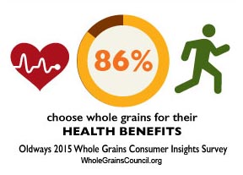

1 in 3 Americans nearly always choose #wholegrains. Five years ago, only 4% did. http://bit.ly/1LFoiXn
Graphic: Survey1_87pc.jpg

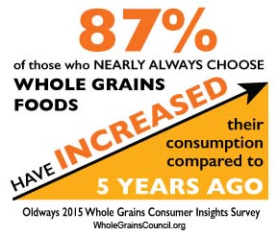

Survey: 7% say they’ve cut gluten entirely; nearly all (93%) eat it some or all the time. http://bit.ly/1LFoiXn
Graphic: Survey1_gf93pc.jpg

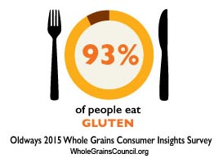

America’s favorite #wholegrains? Wheat, Oats, Rice, Corn top charts (sorry, quinoa). http://bit.ly/1LFoiXn
Graphic: Survey1_favgrains.jpg

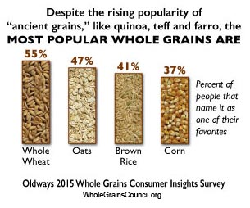

8 in 10 trust the #WholeGrainStamp to accurately state #wholegrains in products. http://bit.ly/1LFoiXn
Graphic: Survey1_breadstamp.jpg

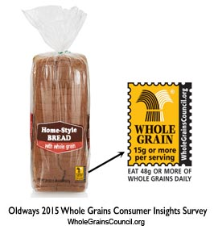

Survey: We eat 37% of our #wholegrains at breakfast, 27% at dinner, 22% at lunch. http://bit.ly/1LFoiXn
Graphic: Survey1_WhenEaten.jpg

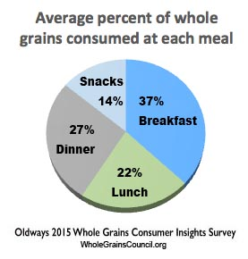

Few know that #gluten is only in wheat, barley, rye. Most #wholegrains are #glutenfree. http://bit.ly/1LFoiXn
Graphic: Survey1_gfdef.jpg

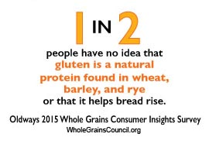

40% of Americans choose #wholegrains for their fuller, nuttier taste, says survey. http://bit.ly/1LFoiXn
Graphic: Survey1_taste40.jpg

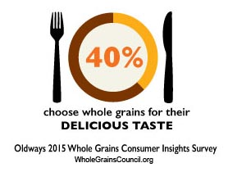

Breads, cereals eaten as #wholegrains more often than refined. Survey at http://bit.ly/1LFoiXn
Graphic: Survey1_breadcereal.jpg

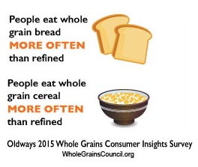

#glutenfree by diagnosis or personal choice? #wholegrains survey finds just 1 in 5 diagnosed. http://bit.ly/1LFoiXn
Graphic: Survey1_gfmedreason.jpg

